Module 2: Baseline Assessment

Session 17: Analysing Baseline Information

Handout 3 – Answers to Cross Checking Exercises

- Income and expenditure cross checks

The boxes to the right (below) indicate four possible cross checks that can be done on this data. The Baseline Storage Sheet does the calculations and displays the results shown automatically. This means that normally this sort of cross checking involves checking, rather than calculating, these figures.

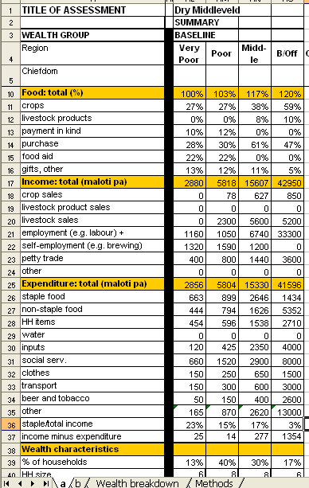

Food income should be at least 90% of kilojoule requirements.
Total income should be roughly the same as total expenditure.

Cash income should increase with wealth group.
Money spent on staple food as proportion of total income or expenditure should decrease with wealth group.

- Labour cross check (i)

Summary: You need to find out how many households the casual work offered by coffee pulping stations could support, and calculate what proportion of total households in the zone this represents.

- How many people in total are employed by pulping stations?
79 stations x 85 workers = ≈ 6,700 workers

- How many households would this support?
Total population in the coffee livelihood zone = ≈ 182,000
Total number of households (assuming av. hh of 7) = ≈ 26,000

- What proportion of households could have a member doing casual work at a pulping station?
6,700 ÷ 26 26,000 = ≈ 26%

- So can most very poor and poor households obtain income from this source?
It is quite possible for all very poor households (15% of all households) to have a member doing this kind of casual work. Some poor households (25% of all households) could also have men doing this work.

- Labour cross check (ii)

The cross check calculations are shown in bold in the shaded rows below:

Labour cross check
Wealth group | Very poor | Poor | Middle | Better off
Number of households | 15 | 25 | 40 | 20
Labour status | Work | Work | Employ | Employ
Birr earned or spent per household | 560 | 370 | 100 | 600
Total amount earned or spent by wealth group | 15 x 560 =  8,400 | 25 x 370 =  9,250 | 40 x 100 =  4,000 | 20 x 600 =  12,000
Total earned | 8,400 + 9,250 = 17,650
Total spent | 4,000 + 12,000 = 16,000

Thus, the total amount earned by the poor and very poor is roughly consistent with the total amount spent by the middle and better-off.

- Land rental cross check

Summary: To check that the land rented out and the land rented in balance, you need to check that the total area of land owned by all households is roughly the same as the total area of land cultivated by all households.

- What is the total area of land owned by all households?
(50 poor households x 3.5) + (30 middle households x 4) + (20 better off households x 4) = 175 + 120 + 80
= 375 timads

- What is the total area of land cultivated by all households?
(50 poor households x 1) + (30 middle households x 6) + 20 better off households x 7.5)
= 50 + 180 + 150
= 380 timads

Conclusion: The total amount of land owned (375 timads) and the total amount of land cultivated (380 timads) balance.

- Crop production cross check: sweet potatoes

Using the figures in the table, it is possible to calculate sweet potato production per household for each wealth group. Production can be calculated in two steps:

(i) Calculate timads planted with sweet potatoes:
- total cultivated area (timads) x % land cultivated with sweet potatoes
(ii) Calculate sweet potato production:
- area planted with sweet potato (timads) x yield (kg/timad)

These calculations are shown in the shaded rows below.

Sweet potato production
Wealth group | Very poor | Poor | Middle | Better off
Total area cultivated (timads) | 0.75 | 1.25 | 2.25 | 4.5
Est. % land planted with sweet potatoes | 30% | 30% | 20% | 10%
Area planted with sweet potatoes (timads) | 0.75 x 0.3 = 0.225 | 1.25 x 0.3 = 0.375 | 2.25 x 0.2 = 0.45 | 4.5 x 0.1 = 0.45
Sweet potato production (kg) | 0.225 x 1,750 = 394 | 0.375 x 1,750 = 656 | 0.45 x 1,750 = 788 | 0.45 x 1,750 = 788
Sweet potato yield = 1,750 kg per timad (all wealth groups)

These figures can then be compared with household production data obtained in interviews with household representatives.

- Crop production cross check: coffee

Using the figures in the table, it is possible to calculate the cash income obtained from coffee production for households in each wealth group. This can be done in two steps:

(i) Calculate coffee produced:
- Number of bushes x yield per bush (kg per bush)
(ii) Calculate income obtained from coffee produced:
- Coffee produced (kg) x coffee price (birr per kg)

These calculations are shown in the shaded cells below.

Coffee production (dry processed)
Wealth group | Very poor | Poor | Middle | Better off
Number of bushes | 12.5 | 25 | 50 | 90
Yield per bush (kg) | 0.9 | 1.0 | 1.1 | 1.2
Coffee produced (kg) | 12.5 x 0.9 = 11.25 | 25 x 1.0  = 25 | 50 x 1.1  = 55 | 90 x 1.2  = 108
Cash income (birr) | 11.25 x 4.5 = 51 | 25 x 4.5  = 113 | 55 x 4.5  = 248 | 108 x 4.5  = 486

These figures showing the cash earned from coffee production can then be compared to those obtained in interviews with household representatives.

